Batch: B1 Roll No.: 1711072

Experiment / assignment / tutorial No. 05

Grade: AA / AB / BB / BC / CC / CD /DD

Signature of the Staff In-charge with date

TITLE :Case Study (for Class Diagram)

AIM: Draw class Diagram for the Library Management System. Clearly show the attributes, multiplicities and aggregations/compositions/Association between classes in the class diagram. And show the implementation of aggregation, association and composition between the classes.
______________________________________________________________________
Expected OUTCOME of Experiment:

CO3: Implement scenarios using object oriented concepts(Drawing class diagram, relationship between classes , sequence diagram)
_____________________________________________________________________
Books/ Journals/ Websites referred:

1.Ralph Bravaco , Shai Simoson , “Java Programing From the Group Up” Tata McGraw-Hill.

2.Grady Booch, Object Oriented Analysis and Design .

_____________________________________________________________________
Pre Lab/ Prior Concepts:

Define Class, Methods, Object.
A class, in the context of Java, are templates that are used to create objects, and to define object data types and methods. Core properties include the data types and methods that may be used by the object. All class objects should have the basic class properties. Classes are categories, and objects are items within each category.

A method is a set of code which is referred to by name and can be called (invoked) at any point in a program simply by utilizing the method's name. Think of a method as a subprogram that acts on data and often returns a value. Each method has its own name.
A Java object is a combination of data and procedures working on the available data. An object has a state and behavior. The state of an object is stored in fields (variables), while methods (functions) display the object's behavior. Objects are created from templates known as classes. In Java, an object is created using the keyword "new".
What is Aggregation and Association.
Aggregation in Java is a relationship between two classes that is best described as a "has-a" and "whole/part" relationship. It is a more specialized version of the association relationship. The aggregate class contains a reference to another class and is said to have ownership of that class. Each class referenced is considered to be part-of the aggregate class. Ownership occurs because there can be no cyclic references in an aggregation relationship. If Class A contains a reference to Class B and Class B contains a reference to Class A then no clear ownership can be determined and the relationship is simply one of association.
Association establishes relationship between two separate classes through their objects. The relationship can be one to one, one to many, many to one and many to many. There are two sub categories of Association: Aggregation and Composition.
List Of Classes:

- Catalogue
- Person
- Customer
- Librarian
- Book
- Transaction
- Main
Identify Attributes in classes:

- Person
- Name
- Age
- E-mail
- Address
- Mobile Number
- Aadhar Number
- Unique Library ID
- Librarian
- Librarian ID
- Customer
- Membership ID
- Transaction
- Transaction ID
- Book
- Title
- ISBN
- Author
- Publishing House
- Year of Print
- Edition
- Price
- Count

Identify List of Methods in classes:

- Person
- Display details.

- Librarian
- Add librarian.
- Search books.
- Add member.
- Remove member.
- Check availability.
- Add books.
- Update edition.

- Customer
- Enrol for membership.
- Search books.
- Issue books.
- Return books.

- Transaction
- Make transaction.
- Report error in transaction.
- Print transaction details.

- Book
- Display book details.

Class Diagram:

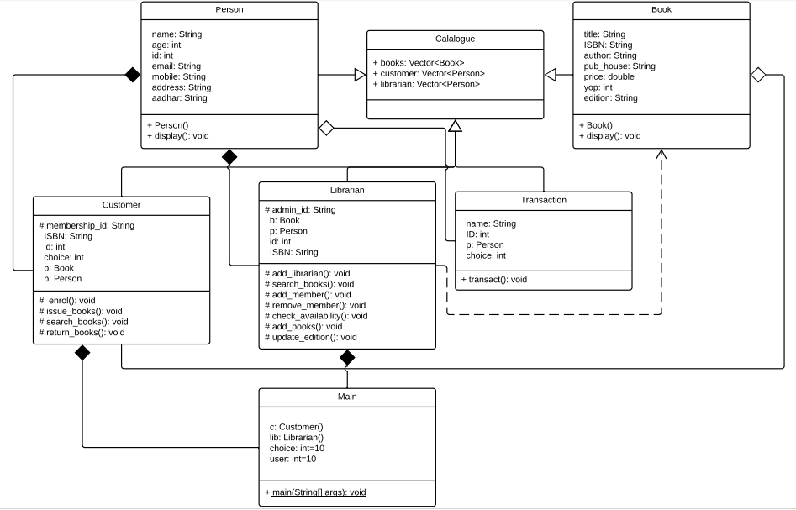
Implementation details:
import java.util.*;
import java.lang.*;
class Catalogue{
public Vector<Book> books=new Vector<Book>();
public Vector<Person> customers=new Vector<Person>();
public Vector<Person> librarian=new Vector<Person>();
}
class Person extends Catalogue{
String name;
int age,id;
protected String email;
protected String mobile;
protected String aadhar;
protected String address;
Person(String name, int age,String email,String mobile, String aadhar, String address, int id){
this.name=name;
this.age=age;
this.email=email;
this.mobile=mobile;
this.aadhar=aadhar;
this.address=address;
this.id=id;
}
public void display(){
System.out.println("USER DETAILS: ");
System.out.println("Name: "+name+"\nAge: "+age+"\nE-mail ID: "+email+"\nMobile Number: "+mobile+"\nAddress: "+address);
}
}

class Librarian extends Catalogue{
protected void add_librarian(){
Person p=new Person("Arghyadeep Das", 19, "arghyadeep.d@somaiya.edu","1234567890", "Secret", "I-335, Shah Arcade, Raintree Marg, Kharghar, Navi Mumbai, Maharashtra-410210, India", 1711072);
librarian.add(p);
p.display();
}
protected String admin_id="123456789";
//Address address=new Address("I-335, Shah Arcade", "Raintree Marg","Kharghar, Navi Mumbai", "Maharashtra", 410210, "India");
protected void search_books(){
System.out.print("Search a book: ");
Scanner sc=new Scanner(System.in);
String book=sc.nextLine();
int flag=0;
for(int i=0;i<books.size();i++){
Book b=books.get(i);
if(b.title.equals(book))
{System.out.println("Book found");
flag=1;}
}
if(flag==0)
System.out.println("Book not found.");
//System.out.println("No such book.");
}
protected void add_member(){
System.out.print("Enter new member details: ");
Person p=new Person("Arghyadeep Das", 19, "arghyadeep.d@somaiya.edu","1234567890", "Secret", "I-335, Shah Arcade, Raintree Marg, Kharghar, Navi Mumbai, Maharashtra-410210, India", 1711072);
customers.add(p);
p.display();
}
protected void remove_member(){
System.out.print("Enter Membership ID of member to be deleted: ");
Scanner sc=new Scanner(System.in);
int id=sc.nextInt();
for(int i=0;i<customers.size();i++){
Person p=customers.get(i);
if(p.id==id)
customers.removeElementAt(i);
}
}

protected void check_availability(){
System.out.print("Enter ISBN number of book whose availability you want to check: ");
Scanner sc=new Scanner(System.in);
String ISBN=sc.next();
for(int i=0;i<books.size();i++){
Book b=books.get(i);
if((b.ISBN).equals(ISBN)){
System.out.println("Book is available");
flag=1;
}
}if(flag==1)
System.out.println("No such book in library.");
}
protected void add_books(){
Book b=new Book("title", "ISBN", "author", "pub_house", 465.30, 2018, "edition",1);
books.add(b);
System.out.println("Book added.");
}

protected void update_edition(){
Book b;
Scanner sc=new Scanner(System.in);
System.out.println("Enter title of book: ");
String title=sc.nextLine();
int flag=0;
for(int i=0;i<customers.size();i++){
b=books.get(i);
if((b.title).equals(title)){
System.out.println("Enter new edition: ");
String edition=sc.nextLine();
b.edition=edition;
break;
}
else
System.out.println("No such book in library");
}
}
}

class Customer extends Catalogue{
void enrol(){
Person p=new Person("Arghyadeep Das", 19, "arghyadeep.d@somaiya.edu","1234567890", "Secret", "I-335, Shah Arcade, Raintree Marg, Kharghar, Navi Mumbai, Maharashtra-410210, India", 1711072);
customers.add(p);
p.display();
}
protected String membership_id;
//Address address=new Address("I-335, Shah Arcade", "Raintree Marg","Kharghar, Navi Mumbai", "Maharashtra", 410210, "India");
protected void search_books(){
System.out.print("Search a book: ");
Book b;
Scanner sc=new Scanner(System.in);
String book_name=sc.next();
for(int i=0;i<books.size();i++){
b=books.get(i);
if(book_name.equals(b.title)){
System.out.println("Book present");
break;
}
System.out.println("Not available.");
}
}
protected void issue_books(){
System.out.print("Do you want to issue this book?(Y/N): ");
Scanner sc=new Scanner(System.in);
String choice=sc.next();
Transaction t=new Transaction();
t.transact();
}
protected void return_books(){
System.out.print("Enter your membership ID: ");
Scanner sc=new Scanner(System.in);
String id=sc.next();
System.out.print("Enter ISBN number of book you wish to return: ");
String ISBN=sc.next();
for(int i=0;i<books.size();i++){
Book b=books.get(i);
if((b.ISBN).equals(ISBN)){
System.out.println("Book returned.");
}
}
}
}

class Transaction extends Catalogue{
public void transact(){
System.out.println("Enter customer details: ");
System.out.print("Enter name: ");
Scanner sc=new Scanner(System.in);
String name=sc.nextLine();
System.out.print("Enter ID: ");
int ID=sc.nextInt();
for(int i=0;i<customers.size();i++){
Person p=customers.get(i);
if((p.name).equals(name) && p.id==ID){
System.out.println("\n1. Credit Card\n2. Debit Card\n3. Net Banking\n4. UPI\n5. Cancel Transaction\n6. Report payment discrepancy\n7. Display Transaction details\n8. Mail transaction details\n9. Generate transaction ID\n0. Exit\nEnter option: ");
int choice=sc.nextInt();
while(choice!=0){
switch(choice){
case 1:
System.out.println("Payment received via credit card.");
break;
case 2:
System.out.println("Payment received via debit card.");
break;
case 3:
System.out.println("Payment received via net banking.");
break;
case 4:
System.out.println("Payment received via UPI.");
break;
case 5:
System.out.println("Transaction cancelled.");
break;
case 6:
System.out.println("We have received your complain and our team will write back to you shortly.");
break;
case 7:
System.out.println("Please find the payment details.");
break;
case 8:
System.out.println("Kindly check your mail. Check spam if not received.");
break;
case 9:
System.out.println("Here's your transaction ID.");
break;
case 0:
System.exit(1);

}
}
}
else
System.out.println("User not present in our database.");
}
}
}

class Book extends Catalogue{
String title, ISBN, author, pub_house, edition;
double price;
int yop, count;
Book(){}
Book(String title, String ISBN, String author, String pub_house, double price, int yop, String edition, int count){
this.title=title;
this.ISBN=ISBN;
this.author=author;
this.pub_house=pub_house;
this.price=price;
this.yop=yop;
this.edition=edition;
this.count+=count;
}
public void display(){
System.out.println("BOOK DETAILS: ");
System.out.println("Title: "+title+"\nISBN: "+ISBN+"\nPublication House: "+pub_house+"\nPrice: "+price+"\nYear of publication: "+yop+"\nEdition: "+edition);
}
}

/**class Address{
String flat,street,city,state,country;
int pincode;
Address(String flat, String street, String city, String state, int pincode, String country){
this.flat=flat;
this.street=street;
this.pincode=pincode;
this.city=city;
this.country=country;
this.state=state;
}
public String toString(){
return flat+", "+street+", "+city+", "+state+", "+pincode+", "+country+".";
}
}
**/
class Main{
public static void main(String[] args){
Scanner sc=new Scanner(System.in);
Customer c=new Customer();
//Book b=new Book();
Librarian lib=new Librarian();
System.out.print("Welcome to Library Management System!");
int user=10, choice=10;
while(user!=0){
System.out.print("\nWho are you?\n1. Customer\n2. Librarian\n3. Exit\nEnter choice: ");
user=sc.nextInt();
switch(user){
case 1:
while(choice!=5){
System.out.print("\n1. New customer\n2. Search books\n3. Issue books\n4. Return books\nEnter a choice: ");
choice=sc.nextInt();
switch(choice){
case 1:
c.enrol();
System.out.println("Customer added.");
break;
case 2:
c.search_books();
break;
case 3:
c.issue_books();
break;
case 4:
c.return_books();
break;
}
}
break;
case 2:
while(choice!=8){
System.out.print("1. Add librarian\n2. Search books\n3. Add members\n4. Remove members\n5. Check availability of a book\n6. Add books\n7. Update edition\nEnter choice: ");
choice=sc.nextInt();
switch(choice){
case 1:
lib.add_librarian();
break;
case 2:
lib.search_books();
break;
case 3:
lib.add_member();
break;
case 4:
lib.remove_member();
break;
case 5:
lib.check_availability();
break;
case 6:
lib.add_books();
break;
case 7:
lib.update_edition();
break;
}
}
break;
case 3:
System.exit(1);
}
}
}
}
For verification, my code can be found at:
https://repl.it/@ARGHYADEEPDAS/ClassDiagram

Conclusion: The program was successfully implemented from the class diagram and we were able to use different types of relationships.

Post Lab Descriptive Questions (Add questions from examination point view)
1. Consider the following class:
public class IdentifyMyParts {
public static int x = 7;
public int y = 3;
}
a) What are the class variables?
Ans. Class variables are variables defined in a class which only have a single copy in memory, regardless of how many instances of the classes exist. In the above case, x is a class variable of type int as it is declared using static keyword.
b) What are the instance variables?
Ans. Instance variables are variables defined in a class which have as many copies in memory as number of instances of the class it is defined in. In the above case, y is an instance variable of type int as it will have a different value and different memory allocation for every instance of the class.
c) What is the output from the following code?
IdentifyMyParts a = new IdentifyMyParts();
IdentifyMyParts b = new IdentifyMyParts();
a.y = 5;
b.y = 6;
a.x = 1;
b.x = 2;
System.out.println("a.y = " + a.y);
System.out.println("b.y = " + b.y);
System.out.println("a.x = " + a.x);
System.out.println("b.x = " + b.x);
System.out.println("IdentifyMyParts.x = " + IdentifyMyParts.x);

Ans.
a.y = 5
b.y = 6
a.x = 2
b.x = 2
IdentifyMyParts.x = 2

Date: 07/09/2018 Signature of faculty in-charge

